ノートパソコンで作業をしている男性

中程度の精度で自動的に生成された説明デスクの上に座っている男性

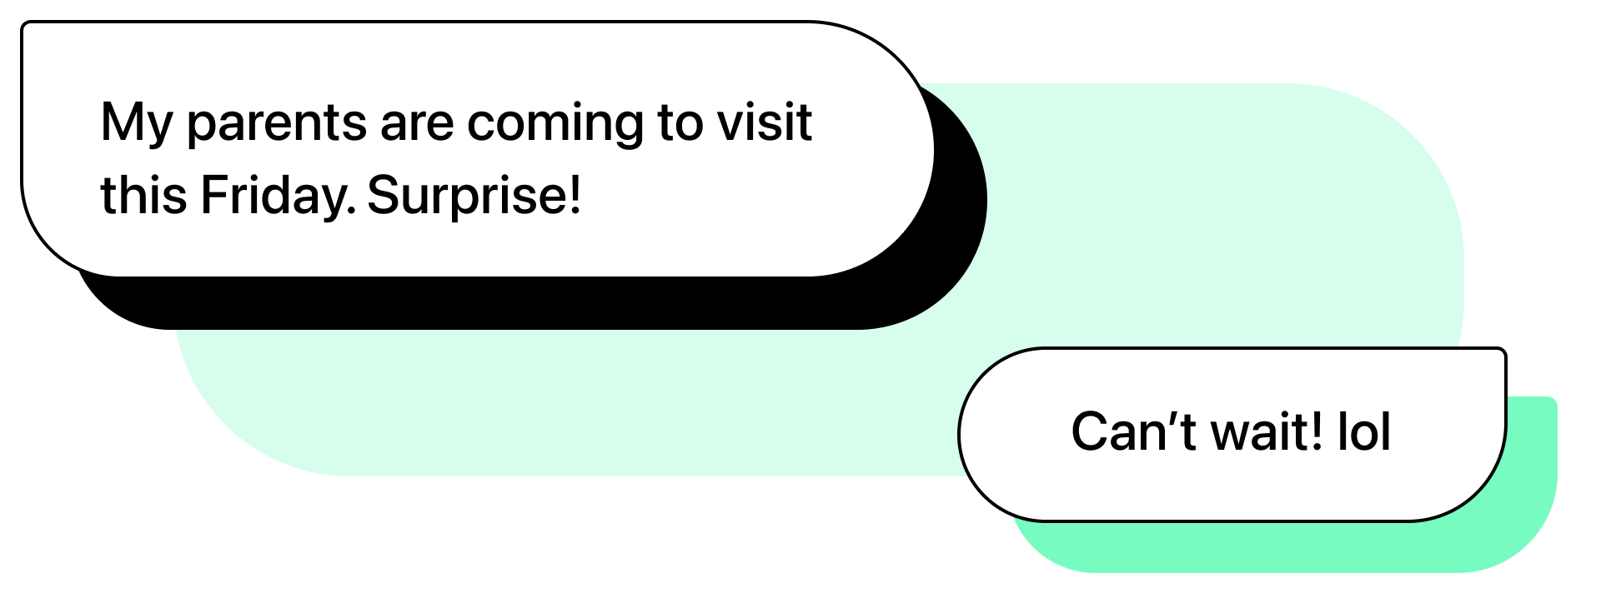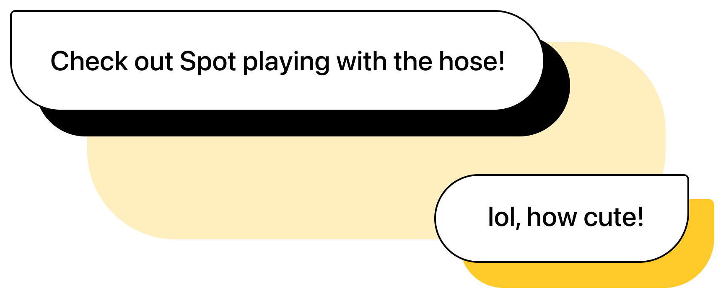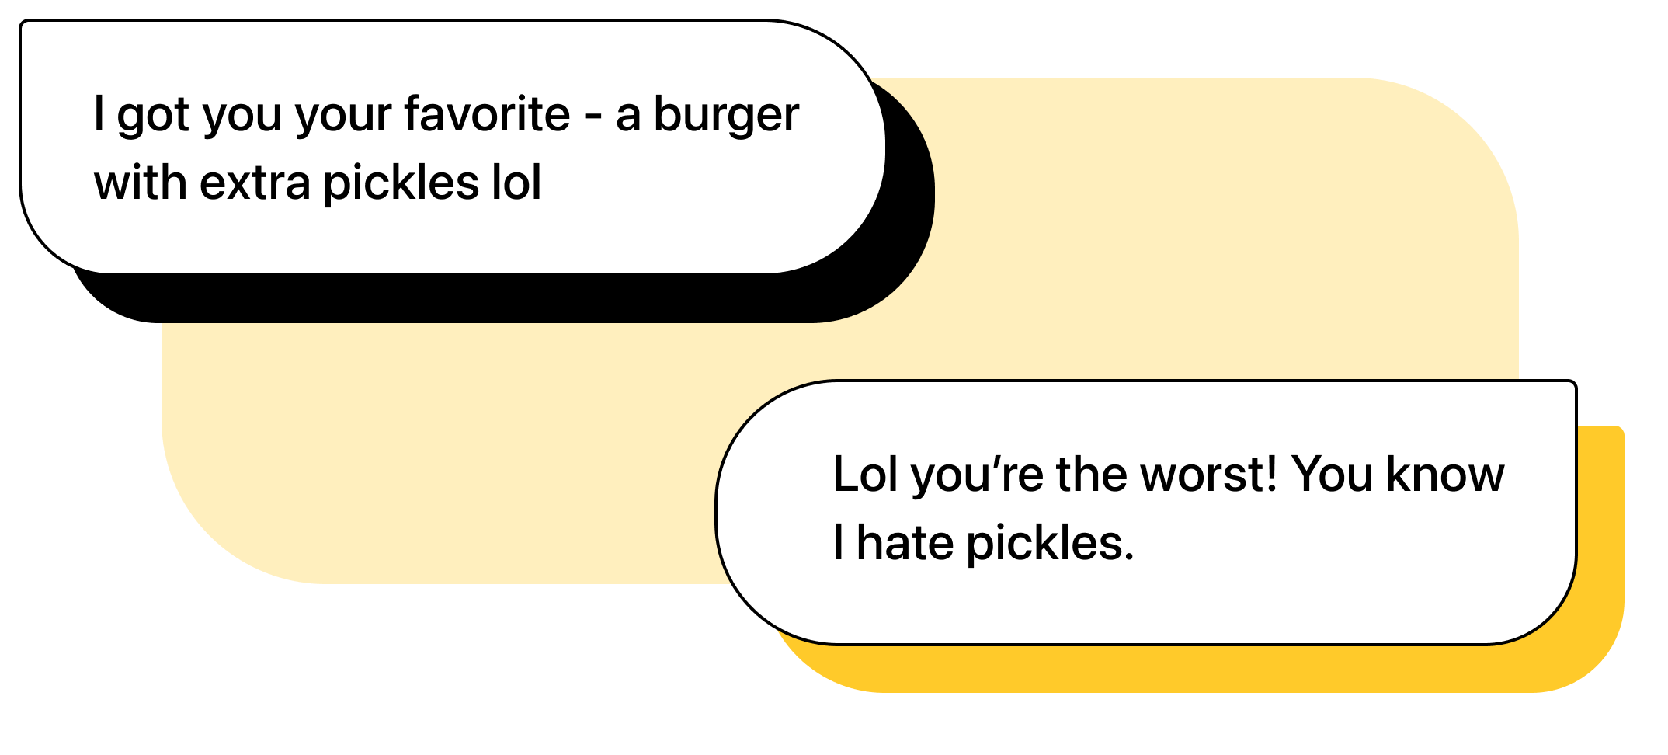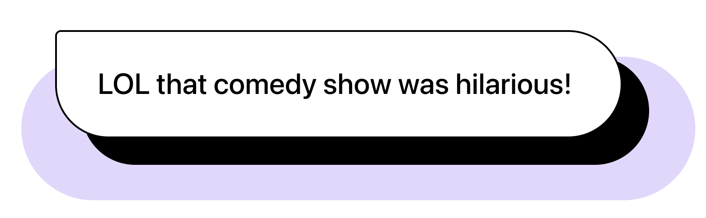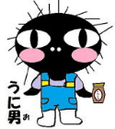

Snapshots: NAPER Week!

1

Texting in English 101: LOL

Here are some examples of LOL in text.

Weekly Spotlight: LOL

Do you know what LOL means? LOL is the short way of saying “Laugh Out Loud.” We use it in different ways:

1) when we think something is funny

2) when we are being sarcastic (口の悪い)

3) when we want to show that we are joking (冗談を言う)

It’s like (笑)!

ALT Mailbox

In Flushing, you can go shopping, eat delicious food, and even go karaoke! You can do many things in Flushing!

What is your favorite book?

Drop your answers in the ALT mailbox near the student entrance!

Upcoming Events

May 31st – June 4th – Inter-High School Tournament

June 12th – Karuta Tournament

June 27th – July 2nd – Exam Week

2

3

The Naru Times

Week of May 20th, 2024 “*Not all those who wander are lost.*” – J.R.R. Tolkien