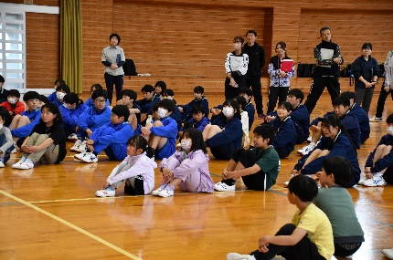床の上にサッカーをしている人達

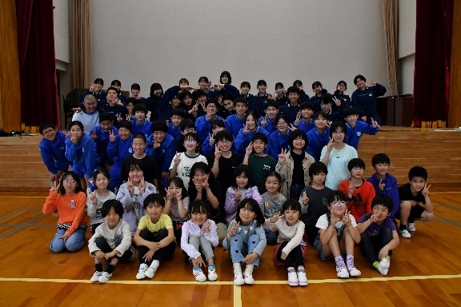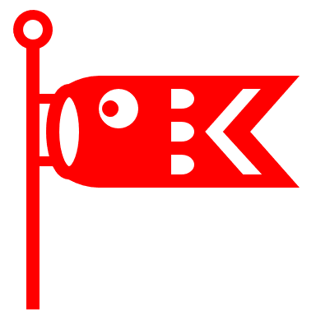 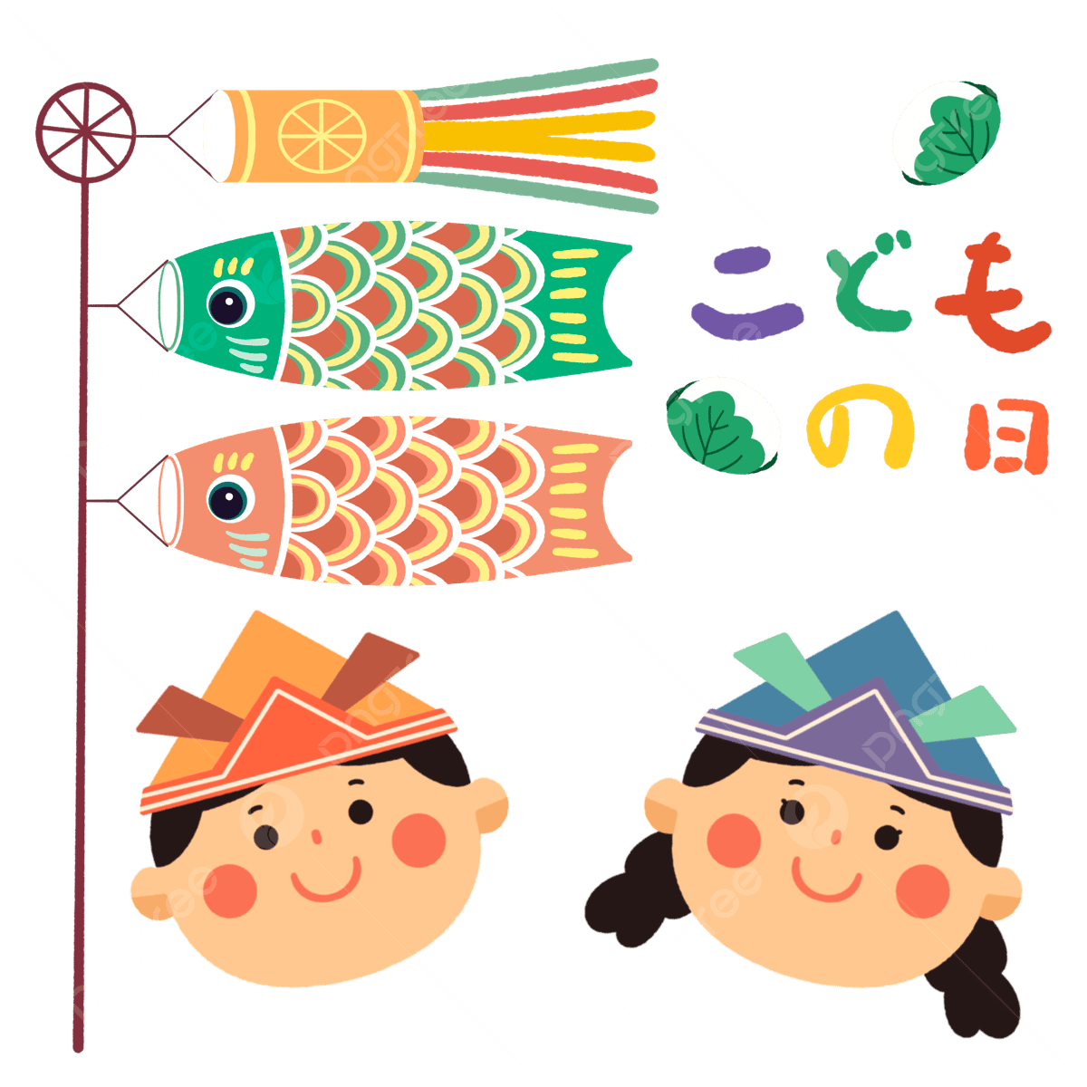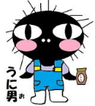

写真: Mr. Oseki

Snapshots: Refresh Day!

Upcoming Events

May 7th – National Teacher Day

May 12th – Mother’s Day

May 13th – 17th – NAPER Week

May 31st – June 4th – Inter-High School Tournament

Character Spotlight: Ron Weasley

Do you know who Ron Weasley (ロン・ウィーズリー) is? Ron is Harry’s best friend. He is from the Weasley family. Ron has 6 siblings (兄弟). He has 5 brothers and 1 sister. He has red hair. Ron is scared of spiders!

ALT Mailbox

What kinds of things do you want to see in Naru Times and on the English board?

Tell Ms. Sophie with the ALT mailbox!

Weekly Spotlight: Harry Potter

Harry Potter is a very famous book series (叢書). It is also a famous movie series.

It is about a boy named Harry. He is a wizard (魔法使い) who lives in England (イギリス). Harry goes to Hogwarts (ホグワーツ) to learn magic. His two best friends are Hermione (ハーマイオニー) and Ron. The three of them go on many magical adventures at Hogwarts.

Let’s read Harry Potter together!

The Naru Times

Week of May 6th, 2024 “*Anything’s possible if you’ve got enough nerve.*” – Ginny Weasley (Harry Potter)